1.1.3 Area of Square - Algorithm, Flowchart and Code

A) Algorithm :
1. Start
2. Read side_length (S)
3. Compute area = S × S (or S²)
4. Display/Print the area
5. Stop

B) Flowchart :
Flowchart diagram:
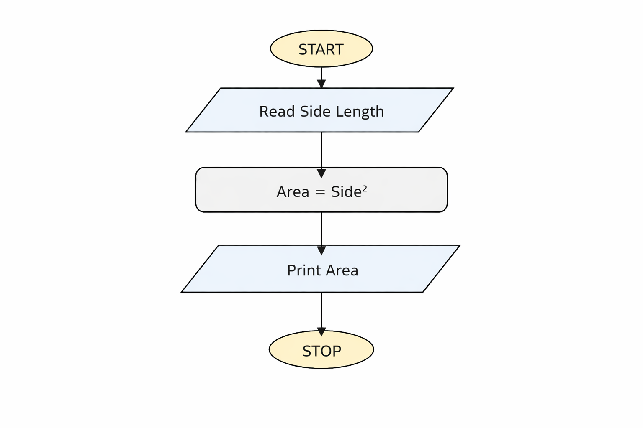

C) Python Code
side_length = int(input())
area = side_length ** 2
print(area)

D) EXECUTION

